25.17: a) From Example 25.1, an 18-gauge wire has 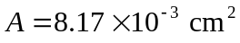
b)
